**TABLE OF CONTENT OF AN INVENTARY SYSTEM OF OUR SCHOOL**

**PROCESS DOCUMENTATION**

1. **PROJECT PLAN**
   1. **Creating a digital solution**
   2. **Generating reports and alerts**
   3. **Preventing losses, thefts, or damages**
   4. **User-friendly interface**
   5. **Compliance with laws and regulations**
   6. **Asset tracking and identification**
   7. **Sign-in and sign-out process**
   8. **Depreciation tracking**
   9. **Operating on a Windows machine**
2. **PERTE CHARTS**
3. **TESTING SCHEDULE**
4. **REPORT**
5. **MEETING NOTES**
   1. **Purpose of the Meeting**
   2. **Agenda**
   3. **Meeting Summary**
   4. **Conclusion**

**PRODUCT DOCUMENTATION**

1. **INTRODUCTION**
   1. **Purpose**
   2. **Document Conventions**
   3. **Intended audience and reading suggestions**
   4. **Project scope**
   5. **References**
2. **OVERALL DESCRIPTION** 
   1. **Description of the ICT Inventory system**
   2. **Product perspective**
   3. **Product features**
   4. **User classes and characteristics**
   5. **Operating environment**
   6. **Design and implementation constraints**
   7. **Assumption and dependencies**
3. **SYSTEM FEARTURES** 
   1. **Functional requirements**
4. **EXTERNAL INTERFACE REQUIREMENT**
   1. **User interfaces**
   2. **Hardware interfaces**
   3. **Software interfaces**
   4. **Communication interfaces**
5. **NONFUNCTIONAL REQUIREMENT**
   1. **Performance requirements**
   2. **Safety requirements**
   3. **Security requirements**
   4. **Software quality attributes**

# PROCESS DOCUMENTATION

## PROJECT PLANS

**Creating a digital solution:** The project aims to develop a digital solution for managing and monitoring the supplies and assets of a school.

**Generating reports and alerts**: The system should be capable of generating reports and alerts regarding inventory levels and trends, providing valuable insights for decision-making.

**Preventing losses, thefts, or damages**: The objective is to implement measures within the system to prevent losses, thefts, or damages to school assets.

**User-friendly interface**: The project deliverable is a user-friendly interface that allows easy access and updating of inventory information.

**Compliance with laws and regulations:** The system must comply with relevant laws, regulations, policies, and standards applicable to inventory management.

**Asset tracking and identification**: The system should track the location of each item, assign identification numbers to assets, and record their normal and current locations.

**Sign-in and sign-out process**: When a student or individual takes an item, they need to provide an ID and sign it out. Similarly, when the item is returned, it should be signed back in.

**Depreciation tracking**: The system should track depreciation values, including the number of damaged items and the amount left in stock.

**Operating on a Windows machine**: The system is designed to run on a Windows

machine locally.

**PERTE CHARTS**

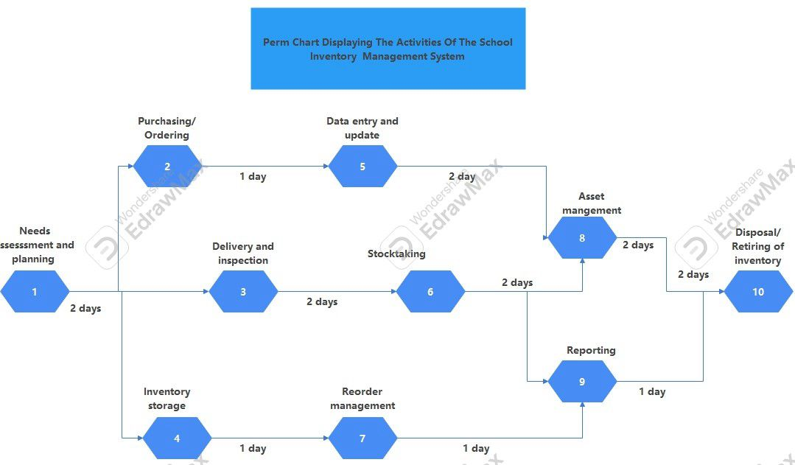

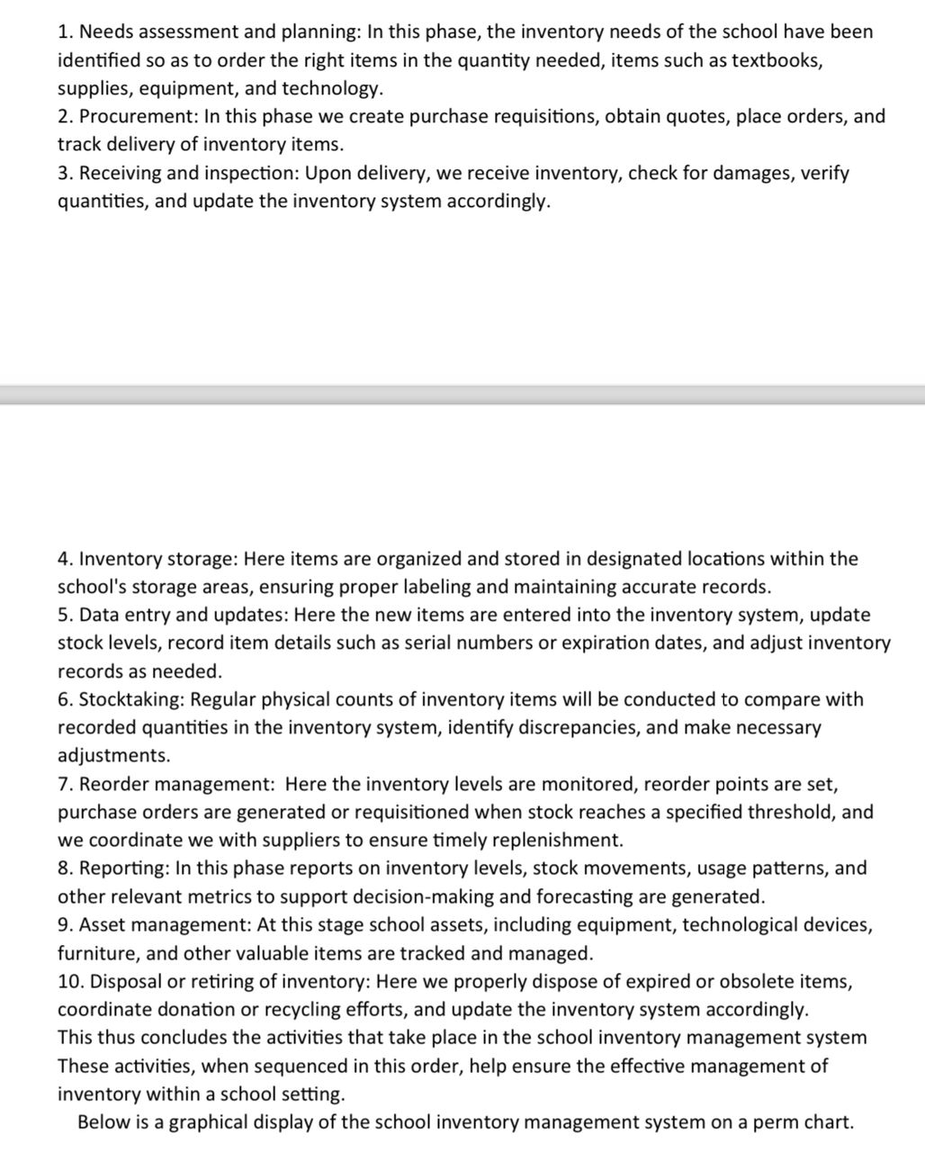

**Test schedule**

**Reports**

**Meeting notes**

**Meeting Report: School Inventory Management System**

**Project Discussions and Work Partition via Slack\***

\***Purpose of the Meeting:**

The purpose of the numerous meetings our team has been having on Slack was to engage in

collaborative conversations related to the development of the school inventory management system project. The objective was to foster open communication, share ideas, and establish a clear work partition for effective task management and progress tracking.

**\*Agenda:**

1. Review of Project Objectives and Scope

2. Discussion of System Modules and Features

3. Task Allocation and Responsibilities

4. Timeline and Milestones

5. Resource Requirements

6. Communication and Collaboration Strategies

**\*Meeting Summary:**

The Slack channel provided a convenient platform for our team to engage in a detailed review of the project's objectives and scope. Discussions revolved around understanding the specific requirements of the school's inventory management needs, aligning these with the desired outcomes of the system, and fostering a shared understanding of the overarching goals.

Our team leveraged the threaded conversation feature on Slack to engage in discussions regarding the various modules and features that would constitute the inventory management system. Each module was analyzed, and the specific functionalities and requirements were identified through interactive discussions, Numerous video and audio calls, Texts, GIF responses, and file sharing to provide visual aids

and examples.

Task allocation and responsibilities were meticulously discussed and assigned using dedicated project management integration within Slack. This allowed for the seamless assignment of specific tasks and roles based on each team member's expertise and experience. This also served as a centralized platform for tracking and updating task progress in real time/onsite.

A detailed timeline and milestones were established and shared within the Slack channel to ensure that all team members were aligned with the project's schedule. Most importantly, Key deliverable and deadlines were agreed upon, and notifications and reminders were set up to keep the team informed and accountable.

Resource requirements, including software tools, hardware, and additional support, were openly

discussed and tracked within the Slack channel. This facilitated swift resolution of resource-related issues and ensured that the team had the necessary resources to carry out their responsibilities effectively.

The Slack channel also served as a means for fostering communication and collaboration strategies which helped to tighten the team’s bond thereby creating a safe space for freedom of expression. Dedicated channels for specific modules or tasks were created to facilitate focused discussions, sharing of relevant documents, and providing a platform for quick decision-making and issue resolution.

**\*Action Items:**

1. Each team member is responsible for updating their task progress in the designated Slack channels and communicating any problems or issues encountered.

2. Notifications and reminders are set up to ensure that key deadlines and milestones are met.

3. Resource requirements and related discussions are actively monitored by the project leader and assistant and addressed within the Slack channel.

\***Next Steps:**

- Our team engaged in ongoing discussions and updates within the Slack channels to ensure smooth progress and effective collaboration.

- We continued to leverage the features of Slack for efficient task management, real-time

communications, and knowledge sharing.

**\*Conclusion:**

The meetings on Slack have always concluded with a sense of shared commitment and enthusiasm from all team members to successfully deliver the school inventory management system. The platform's seamless integration with project management tools and its ability to facilitate open communication and task tracking were necessary in fostering a cohesive team effort.

**PRODUCT DOCUMENTATION**

**1. Introduction**

**1.1 Purpose**

This inventory system is to help facilitate and manage assets, resources, and infrastructure efficiently and effectively. This covers all things used by staff and students, such as equipment, supplies, books, and furniture.

**1.2 Documents Conventions**

So in this document our headings a bonded and underlined while sub heading are bonded and every subheadings are clearly and briefly explained

**1.3 Intended audience and reading suggestions**

The software requirement specifications document is written for a general audience, this document is intended for individuals directly involved in the development of an inventory system in our school.

**1.4 Project scope**

Our project aims to create a digital solution for managing and monitoring the supplies and assets of a school. The solution will include the following;

* Project description

Generating reports and alerts on inventory levels and trends

* Project objectives

Prevent losses, thefts, or damages of school assets

* Project deliverable

A user-friendly interface that allows users to access and update inventory information easy

* Project Exclusions

Any additional features or functionalities that are not specified in this document

* Project constraints

Project must comply with relevant laws, regulations, policies, and standards

* Project assumptions

Students has provided all necessary data and information for creating and accurate inventory data base

**1.5 project reference**

Authors” SHUYE ANITA, FOSANG CHE, MVOGO CHRISTOPHE, NYAPEM JOYCE PATRICIA.

Year (2023)

Title of document INVENTARY SYSTEM OF OUR SCHOOL REQUIREMENTS

Date 10th December 2023

Collection name

Document number

Name of archive

Location of archive

**2. Overall description**

**2.1 Description of the ICT inventory system**

The ICT University currently has an inventory system, and it is divided into two. We have fixed assets, and we have office supplies, but however, we are interested in the fixed assets. In the ICT department we use the following equipment for projectors, HDMI cables, Sockets, Monitor screens, RJ45 cables, etc. Every year, the Finance office ensure that they inventory the equipment directly into the system as they arrive and add it to the existing stock and they are costed every year, that is, their value should decrease over time. When they go out for use, they are removed from the system. Each asset or equipment has a cooperate user, for example students and lecturers make use of the HDMI cables and projectors during their classes. Since every asset has a cooperate user, each item’s location must be tracked when taken. When a student comes to take an equipment from the CISCO lab, he needs to leave his School ID or personal ID so that they know which exact student went with the material. The problem with the current system is that, the system does not track the location of these items, as they are been moved and each item does not have an Identification number. For them to know the materials available they must do it manually. To ameliorate the system, the system should have identification numbers for each item, give their normal location, and their current location when they have been taken. When any individual takes an item, he provides an ID and signs it out, when the item returns, he/she signs it in. So, the system should know when things go out and when things go back, depreciation value, that is, how many are bad, amount left in stock. The system obviously runs on a windows machine, and locally.

**2.2 product perspective**

* Product name
* System interface
* User interface
* Hardware interfaces
* Software interfaces
* Communication interfaces
* Memory
* Operations
* Site adaption requirements

**2.3 Product features**

School inventory system is a crucial tool for managing and tracking various resources within an educational institution. Here are some key features of a school inventory system;

1. Equipment inventories: These are used to record all physical properties present within the schools vicinity. It’s mostly used by maintenance and security department.
2. School data inventory: created to assure that data resources needed by students are organized and can be used right away when needed.
3. School Bus Inventory: used to identify the current condition of the school buses owned by the academic institution.
4. Unified inventory tracking: This Feature allows for the categorization of different type of assets for easier identification.
5. Regular inventory counts: Regular inventory checks help to ensure that item can be reordered in a timely manner based on demand.
6. Unique identification numbers: having unique identification numbers for items makes it easier to store and access information
7. Reporting and Business intelligence: This features helps in tracking inventory and making informed decisions.
8. Forecasting inventory: This helps in predicting the future needs of the inventory
9. Alerts and notification : these are used to inform about any changes or updates in the inventory
10. Security Encryption and backups: these features ensure the safety and security of the inventory data.
11. Integration support: This allows the inventory system to be integrated with other system for better functionality
12. Cloud readiness: this feature allows the inventory data to be stored and accessed from the cloud
13. Real time update currency support: This ensures that the inventory data is always up-to-date.

**2.4 User classes and characteristics**

Designing and implementing a school inventory system comes with several constraints.

Budget Constraints: The cost of implementing the system can be a significant constraint.

Technical constraints: The system must be compatible with the existing IT infrastructure of the school

User skills level: The system must be user friendly and easy to use, considering the varying levels of technical skills among the users.

Data migration: If the school is transitioning from a manual or another digital system, migrating existing data into the new system can be a complex task.

Integration with other systems: May need to integrate with other system used by school management system

Security and privacy: The system must ensure the security and privacy of the data it handles

Scalability: The system should be able to accommodate the growth of the school terms of the number of students, staff, and inventory items

Reliability and availability: The system should be reliable and available whenever it’s needed

Maintenance and support: Ongoing maintenance and support are necessary to ensure the system continues to function effectively

Maintenance and Support: Ongoing maintenance and support are necessary to ensure the system continues to function effectively

**2.5 Operating environment**

The operating of a school inventory system refers to the condition and elements that the system operates within. These are the key aspects

Physical Environment: The system is used in an educational institution, which includes classrooms, libraries, laboratories, sports facilities, and administrative offices.

Digital Environment: The system may be cloud-based, allowing for real-time updates and remote access. It may also integrate with other systems used by the school.

User Environment: The system is used by various user classes, including administrators, teachers, students, inventory managers, maintenance staff, librarians, and IT staff.

Regulatory Environment: The system must comply with any relevant laws and regulations, such as data privacy laws.

Technological Environment: The system may use technologies like bar-codes or RFID tags for tracking items. It may also provide alerts and notifications, and support for planning device repair and maintenance.

Operational Environment: The system operates within the academic calendar, with inventory turnover often aligning with academic semesters.

7. Financial Environment: The system plays a crucial role in managing the school's finances, as different types of inventory make up a substantial portion of the school's assets and budgets.

8. Educational Environment: The system supports educational activities by ensuring that necessary resources are available when needed.

These aspects collectively form the operating environment of a school inventory system. The system should be designed to operate effectively within this environment.

**2.6 Design and implementation constraints**

1. Budget Constraints: The cost of implementing the system can be a significant constraint. This includes the cost of software development, hardware, training, and maintenance.

2. Technical Constraints: The system must be compatible with the existing IT infrastructure of the school. This includes hardware, software, and network compatibility.

3. User Skill Level: The system must be user-friendly and easy to use, considering the varying levels of technical skills among the users.

4. Data Migration: If the school is transitioning from a manual or another digital system, migrating existing data into the new system can be a complex task.

5. Integration with Other Systems: The inventory system may need to integrate with other systems used by the school, such as the school management system.

6. Security and Privacy: The system must ensure the security and privacy of the data it handles. It should comply with relevant laws and regulations.

7. Scalability: The system should be able to accommodate the growth of the school in terms of the number of students, staff, and inventory items.

8. Reliability and Availability: The system should be reliable and available whenever it is needed.

9. Maintenance and Support: Ongoing maintenance and support are necessary to ensure the system continues to function effectively.

These constraints need to be considered during the design and implementation phases to ensure the successful deployment of the system.

2.**7Assumption and dependencies**

**Assumptions:**

1. Data Entry: It is assumed that the office personnel do all the data entry based on the correct values obtained from forms and registers.

2. User Training: It is assumed that all users of the system, including administrators, teachers, and staff, are trained to use the system effectively.

3. Availability of Resources: The system assumes the availability of necessary hardware and software resources.

4. Reliable Internet: If the system is cloud-based, it assumes a reliable internet connection for real-time updates and remote access.

**Dependencies:**

1. IT Infrastructure: The system depends on the existing IT infrastructure of the school, including hardware, software, and network compatibility.

2. Vendor Support: The system's functionality and maintenance depend on the support provided by the software vendor.

3. User Participation: The effectiveness of the system depends on the active participation of all users in keeping the inventory data up-to-date.

4. Regulatory Compliance: The system's operation depends on compliance with relevant laws and regulations, such as data privacy laws.

These assumptions and dependencies are crucial for the successful implementation and operation of a school inventory system.

**3. SYSTEM FEATURES**

* 1. **Functional requirements**

1. The functional requirements of a school inventory system define what the system should do. Here are some common functional requirements.

1. Inventory Management: The system should be able to track all items in the inventory, including their current status (e.g., checked out, available, under maintenance) and location.
2. Transaction Management: The system should support the insertion, modification, deletion, cancellation, and error checking of transactions.
3. User Management: The system should allow administrators to add, remove, and manage user accounts.
4. Reporting: The system should generate reports on inventory usage, including checkouts, returns, and overdue items.
5. Search Functionality: Users should be able to search the inventory based on various criteria, such as item name, category, or location.
6. Notifications: The system should send notifications for important events, such as overdue items or low inventory levels¹².
7. Integration: The system should integrate with other systems used by the school, such as the school management system.
8. Security: The system should have authentication and authorization mechanisms to ensure that only authorized users can access the system and perform certain actions.
9. Data Backup and Restoration: The system should have mechanisms for backing up and restoring data.
10. Local Store Management: The system should be able to manage local stores.

11. Retailer's Privacy: The system should ensure the privacy of the retailers.

1. These functional requirements help ensure that the school inventory system can effectively manage and track the school's resources.

**4. EXTERNAL INTERFACE REQUIREMENT**

**4.1 User Interface**

The user interface requirements for a school inventory system typically include the following:

1. Dashboard: A modern dashboard user interface for school management systems can include various elements for teachers, parents, and administrators. This dashboard can provide an overview of the inventory status, recent transactions, and alerts for low stock or expiring items.

2. Inventory Management: This interface allows users to track and manage hundreds, if not thousands, of assets. It can include features for entering item identification, quantities, locations, and other details.

3. Asset Tracking: This feature helps asset managers understand where the school’s assets are at

all times. It can include functionalities like assigning bar-codes to smart devices and other supplies, and monitoring and locating borrowed assets faster with shared registry and tracking tags.

4. Reporting: This interface can capture devices’ status in real-time, perform inventory-related tasks remotely, and generate instant performance reports for inventory items.

5. Administrative Coordination: This can include planning device repair and maintenance to minimize device downtime, coordinating administrative activities, and managing fees.

6. Communication Tools: These facilitate teacher-parent interactions.

Remember, the exact user interfaces can vary based on the specific needs of the school and the software solution they choose to implement. It’s also important to note that a well-designed user interface can greatly enhance the efficiency of inventory management in schools.

**4.2 The hardware interface**

Requirements for a school inventory system can vary based on the specific needs of the school and the software solution they choose to implement. However, here are some common hardware interfaces that are typically required:

1. Computers: The school inventory system will require computers capable of running the inventory management software. These computers should have modern operating systems, sufficient processing power, and enough random-access memory (RAM) to handle the software.

2. Bar-code Scanners: These are used to scan bar-codes or QR codes assigned to smart devices and other supplies. This helps in tracking and locating borrowed assets faster with shared registry and tracking tags.

3. Printers: Printers may be needed to print bar-codes, QR codes, or other labels for inventory items.

4. Network Devices: Routers, hubs, switches, and access servers may be needed for communications support.

5. Mobile Devices: Tablets or smartphones can be used for remote access to the inventory system, allowing staff to update inventory records on the go.

Remember, the exact hardware requirements can vary based on the specific needs of the school and the software solution they choose to implement. It’s also important to note that a well-designed hardware interface can greatly enhance the efficiency of inventory management in schools

**4.3 The software interface**

Requirements for a school inventory system can vary based on the specific needs of the school and the software solution they choose to implement. However, here are some common software interface requirements that are typically needed:

1. Functional Requirements: These include features like adding and removing teachers/staff details, student details, managing payment of student fees and salary for faculty, getting reports of student activities and faculty performance, and allowing adding of marks and attendance by faculty members.

2. Non-functional Requirements: These include security (only authorized users must be able to access the system and view and modify the data), user-friendliness (the system should provide an interactive user-friendly interface that is easily understandable for all users), dependability (the system should provide consistent performance with easy tracking of records and updating of records), and maintainability (the system should be easily maintainable and adding and removing new features must be very easy).

3. Platform Requirements: The system should be compatible with modern operating systems like

Windows Server or Linux.

4. Language Requirements: The system should be developed in a multi-threading capable OOP

based language like Java, C++, Python, etc.

5. Database Requirements: The system should use a Relational DBMS like MySQL or PostgreSQL.

6. Front-end Frameworks: The system should use modern front-end frameworks like Angular, React. Remember, the exact software requirements can vary based on the specific needs of the school and the software solution they choose to implement. It’s also important to note that a well-designed software interface can greatly enhance the efficiency of inventory management in schools

**4.4 The communication interface**

Requirements for a school inventory system can vary based on the specific needs of the school and the software solution they choose to implement. However, here are some common communication interface requirements that are typically needed:

1. Two-Way Communication: The system should assist in two-way communication with students and their parents. This can be facilitated through email notifications, SMS alerts, or in-app messaging.

2. Shared Registry and Tracking Tags: The system should allow for monitoring and locating borrowed assets faster with shared registry and tracking tags. This can be facilitated through RFID tags, bar-codes, or QR codes.

3. Remote Access: The system should allow for performing inventory-related tasks remotely. This can be facilitated through a web interface or a mobile app.

4. Real-Time Updates: The system should provide real-time updates on the status of inventory items. This can be facilitated through push notifications or live dashboards.

5. Integration with Other Systems: The system should be able to integrate with other systems used by the school, such as the school management system or the financial system. This can be facilitated through APIs or other integration technologies.

Remember, the exact communication interface requirements can vary based on the specific needs of the school and the software solution they choose to implement. It’s also important to note that a well- designed communication interface can greatly enhance the efficiency of inventory management in schools.

**5. NONFUNCTIONAL REQUIREMENTS**

**5.1 Performance requirement**

Performance requirements might encompass:

1. Response Time:

- Ensure the system responds within an acceptable time frame for user queries and transactions.

2. Scalability:

- The system should be able to scale to handle an increasing number of assets and users without a significant drop in performance.

**5.2 Safety requirements**

1. Data Backup and Recovery:

- Implement regular data backups and establish a robust recovery plan to prevent data loss in case of system failures.

2. Audit Trails:

- Maintain detailed audit trails to trace changes in the inventory system, ensuring accountability and aiding in investigations if needed.

**5.3Security requirements**

1. Data Encryption:

- Utilize encryption mechanisms to protect sensitive data during transmission and storage.

2. Access Controls:

- Implement granular access controls to restrict access to confidential information based on user roles.

3. Security Audits:

- Conduct regular security audits to identify and address potential vulnerabilities in the system.

These requirements collectively contribute to building a reliable, efficient, and secure ICT inventory system.

* 1. **Software quality attributes**

Software attributes for an ICT inventory system encompass various qualities that contribute to its overall effectiveness and performance. Some key software attributes include:

1. **Reliability:**

- The system should consistently perform its intended functions accurately and without unexpected failures.

2. **Maintainability:**

- Design the software to be easily maintainable, allowing for updates, bug fixes, and improvements without disrupting normal operations.

3. **Flexibility**:

- Ensure the system can adapt to changes in business processes, technology, and requirements without significant re-engineering.

4. **Scalability**:

- Design the increase architecture to scale efficiently as the volume of inventory data and user interactions increases.

5. **Usability:**

- Provide an intuitive and user-friendly interface to facilitate easy navigation and efficient use of the system.

6. **Interoperability:**

- Enable seamless integration with other relevant systems and technologies to support a connected IT environment.

7**. Performance Efficiency**:

- Optimize the software's performance to ensure it operates efficiently, responding quickly to user requests and processing data in a timely manner.

8. **Security:**

- Incorporate robust security measures to protect sensitive data, prevent unauthorized access, and mitigate potential vulnerabilities.

9. **Compatibility:**

- Ensure compatibility with different devices, browsers, and operating systems to maximize accessibility.

10. **Compliance**:

- Adhere to relevant industry standards, regulations, and compliance requirements to ensure legal and ethical usage.

11. **Error Handling:**

- Implement effective error handling mechanisms to provide meaningful error messages and recover gracefully from unexpected situations.

Considering these software attributes alongside functional and non-functional requirements will contribute to the development of a robust and reliable ICT inventory system.

# Business logic

The business logic focuses on improving inventory management, asset tracking, user accountability, integration with existing systems, reporting and analytic, and ensuring a user-friendly and efficient system for managing school resources and assets.

**Tracking and Recording**: The software should accurately track and record the entry and exit of inventory items. It should maintain a detailed database of all items, including their identification numbers, descriptions, and current locations.

**User Identification**: When a user borrows an item, they must provide their ID (e.g., School ID or personal ID) to associate the item with the responsible user. This helps in maintaining accountability and tracking the location of items.

**Location Tracking**: The system should keep track of the current location of each item. When an item is taken, its location should be updated accordingly. This allows users to easily locate items and prevents loss or misplacement.

**Item Availability**: The software should provide information on the availability of inventory items. Users should be able to check whether an item is currently in stock or if it has been borrowed by someone else.

**Depreciation and Stock Management**: The system should handle depreciation of assets over time. It should record the condition of items, track the number of damaged or non-functional items, and provide information on the remaining stock.

**Borrowing and Returning Process**: The software should facilitate the borrowing and returning process. Users should be able to sign items out when borrowing them and sign them back in upon returning. This helps maintain a clear record of item movements.

**Notifications and Alerts**: The system should notify users and administrators about low stock levels, damaged items, or other inventory-related issues. Notifications can be sent via email or other communication channels to ensure prompt action.

**Reporting and Analytic**: The software should generate reports and provide analytic related to inventory management. This includes generating performance reports for items, analyzing stock levels and trends, and providing insights for decision-making.

**Integration with Financial Office**: The inventory system should integrate with the financial office or accounting software to exchange relevant data. This ensures accurate inventory records and facilitates financial tracking and reporting.

**Search and Retrieval**: The software should provide search functionality to allow users to locate specific inventory items quickly. Users can search by keywords, item descriptions, or other relevant criteria to find the desired items efficiently.

# USER-MANUAL

**User Manual: School Inventory System**

Table of Contents

# [Logo or Graphic]

# School Inventory System User Manual

# Version 1.0

# 1. Introduction

The ICT Department Inventory System is a comprehensive software solution designed specifically for the Information and Communication Technology (ICT) department within a school. It serves as a centralized platform for efficiently managing and tracking the inventory of technological equipment, software licenses, and other IT-related resources used by the department.

This inventory system offers several key benefits to the ICT department. It enables better control and organization of ICT assets, ensuring that the department has an accurate and up-to-date record of the equipment available. By maintaining a clear overview of the inventory, the ICT department can optimize resource allocation, plan for upgrades, and ensure the smooth functioning of technology within the school.

With the ICT Department Inventory System, staff members can easily track the location, condition, and maintenance history of ICT assets. This streamlines the process of borrowing equipment, scheduling maintenance tasks, and identifying items that require repair or replacement. By automating these processes, the system increases efficiency and reduces the risk of equipment loss or misuse.

Furthermore, the ICT Department Inventory System promotes collaboration and communication among staff members. It enables seamless sharing of information about inventory availability, equipment reservations, and upcoming maintenance activities. This fosters better coordination within the department and ensures that resources are effectively utilized.

This user manual provides detailed instructions on how to utilize the ICT Department Inventory System effectively. It covers various functionalities, including user login, adding items to the inventory, editing and deleting items, signing out items to institution members, returning items, generating reports, and more. Refer to the subsequent sections for step-by-step instructions on using the system to streamline inventory management within the ICT department.

Thank you for choosing the ICT Department Inventory System to enhance the efficiency and organization of your school’s ICT resources. We are confident that this system will greatly benefit the ICT department and contribute to the overall success of your educational institution.

# 2. Login

To log in to the ICT Department Inventory System, follow these steps:

1. Launch the application by clicking the “Launch App” button found at the top of Sheet1.
2. A login form will appear, asking for user credentials.
3. Enter “emmanuel” for the username and “password” for the Password field.
4. Click the “Login” button at the bottom of the pop-up window.
5. If the information is entered correctly, you will be taken to the main view/dashboard.
6. If the information entered is incorrect, you will see a red text indicating that the information you entered is invalid. Please go back and refill the username and password fields correctly, and then retry step 4.

Please note that the provided username and password are for demonstration purposes only. In a live system, you would use the appropriate credentials provided by your system administrator.

# 3. Add Items to Inventory

To add items to the inventory, follow these steps:

1. Click the “Add” button at the top right of the main view/dashboard.
2. A new window will open with input fields to fill.
3. Fill in all the required fields denoted by (*).
4. Click the “Add” button at the bottom right.
5. You will receive a message indicating that the adding process was successful.
6. If you wish to cancel the add process, click the “Cancel” button located near the “Add” button.

Please ensure that you provide accurate and complete information while adding items to the inventory.

# 4. Edit Item in Inventory

To edit an existing item in the inventory, follow these steps:

1. Click on the “Inventory Item” tab in the main view.
2. Select the item you wish to edit by clicking on it.
3. Click the “Edit” button at the top right corner.
4. A window will open with already populated input boxes.
5. Change the required information in any input box.
6. Click the “Edit” button at the bottom right.
7. A message box should appear indicating that the item was successfully edited.
8. If you wish to cancel the editing process, click the “Cancel” button located near the “Edit” button.

Please ensure that you review and verify the changes before saving the edited item.

# 5. Delete Item in Inventory

To delete an item from the inventory, follow these steps:

1. Click on the “Inventory Item” tab in the main view.
2. Select the item you wish to delete by clicking on it.
3. Click the “Delete” button at the top right corner.

Please exercise caution while deleting items as this action is irreversible.

# 6.Sign Out Items to Institution Members

To sign out items to institution members, follow these steps:

1. Click the “Sign Items” tab in the main view.
2. Select the item you wish to sign out by clicking on it.
3. Click the “Sign Out” button at the top right corner.
4. A new window will open with a list of institution members.
5. Select the member you wish to sign out the item to by clicking on their name.
6. Click the “Sign Out” button at the bottom right.
7. A message box should appear indicating that the item was successfully signed out.

Please ensure that you select the correct institution member and provide accurate information while signing out items.

# 7. Return Items

To return items that have been signed out, follow these steps:

1. Click the “Return Items” tab in the main view.
2. Select the item you wish to return by clicking on it.
3. Click the “Return” button at the top right corner.
4. A message box should appear indicating that the item was successfully returned.

Please ensure that you select the correct item for return.

# 8. Generate Reports

To generate reports based on the inventory data, follow these steps:

1. Click the “Reports” tab in the main view.
2. Select the type of report you would like to generate (e.g., “Inventory Summary,” “Items Signed Out,” etc.).
3. Click the “Generate Report” button.
4. A report will be generated and displayed on the screen.
5. You can print the report or save it as a PDF file using the available options.

Please note that the report generation process may take a few moments, depending on the size of the inventory data.

# 9. Troubleshooting

If you encounter any issues or errors while using the ICT Department Inventory System, please follow these troubleshooting steps:

1. Check the error message displayed on the screen for any specific details about the problem.
2. Refer to the “FAQ” section of this user manual for common troubleshooting tips.
3. If the issue persists, contact your system administrator or IT support team for further assistance.

Please provide them with the necessary information, such as the steps leading to the error and any error messages displayed on the screen.

Thank you for using the ICT Department Inventory System. We hope this user manual has provided you with the necessary guidance to effectively manage and track your school’s ICT resources. If you have any questions or require further assistance, please don’t hesitate to reach out to our support team.

**Names**

**NJIANGA AYOUBA ICTU20222964**

**NGANE EMMANUEL ICTU20222972**

**YOHMEH MARC BIAN BILINGWE ICTU20223131**

**NSAILA RIDLEY.N ICTU20222976**

**NGANKAM FOTSING RYAN ICTU20223412**

**SHUYE ANITA BERINYU ICTU20223188**

**MVOGONKA CHRISTOPHE ICTU20222936**

**FOSANG CHE ICTU20222990**

**NYAPEM JOYCE PATRICIA ICTU20223516**

**TANYU RANSOM TUWA ICTU20233584**